**DAD 220 Cardinality and Targeted Data Template**

Replace the bracketed text in this template with your screenshots and responses. Then submit it to the Module Four Lab for submission, grading, and feedback. Screenshots should be sized to approximately one quarter of a page. Written responses should be in complete sentences. Rename this document by adding your last name to the file name before you submit.

1. **Retrieve employee tuples and identify the number of employees** in San Francisco and New York.

[Insert a screenshot of both tables (they should both fit in one screenshot) here.]

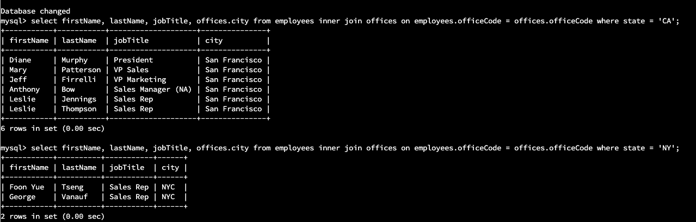

1. **Retrieve order details** for orderNumber 10330, 10338, and 10194 and **identify** what **type of cardinality** this represents in the entity relationship model.

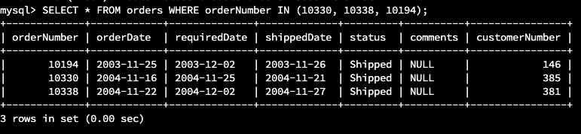

* 1. One customer can have zero to many orders.
  2. One order can have many OrderDetails.
  3. High cardinality with One-to-Zero
  4. OrderNumbers are distinctive and are not duplicated
  5. Every entry in the Orders table can have one-to-many rows in OrderDetails table

1. **Delete records** from the payments table where the customer number equals 103.

[Insert a screenshot of this data before you delete it here.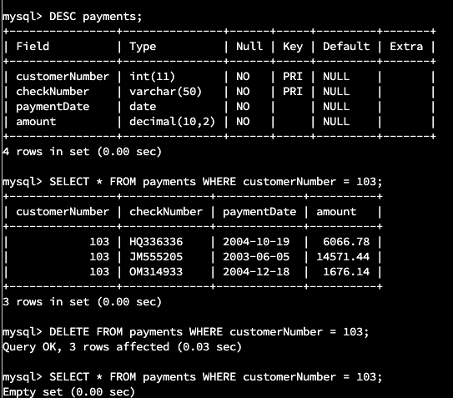

[Insert a screenshot showing that you have successfully deleted these records here.]

1. **Retrieve customer records** for sales representative Barry Jones and **identify** if the **relationships** are one-to-one or one-to-many**.**
   1. One-to-many

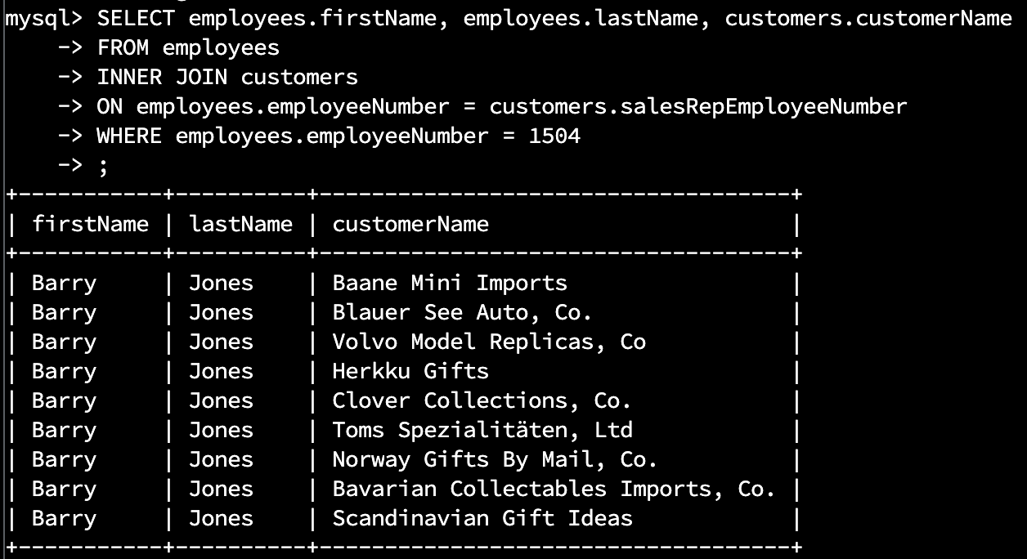

1. **Retrieve records** for customers who reside in Massachusetts and **identify** **their sales rep and the relationship of entities**. Identify if these entities demonstrate one-to-one or many-to-many relationships.
   1. A single sales rep can have many customers. One-to-Many relationship.

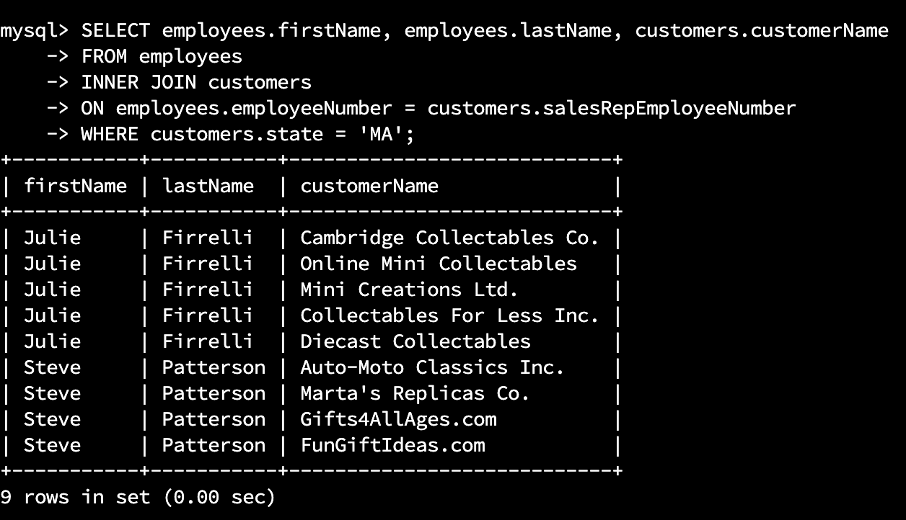

1. **Add one customer record** with your last name using an INSERT statement. You may use the name of a celebrity or fictional character if you don’t use your own name.
   1. [Insert a screenshot of your unique customer record here.]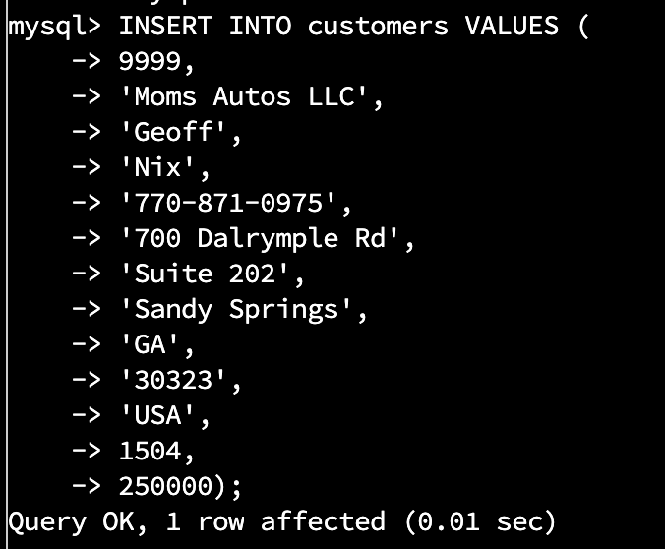

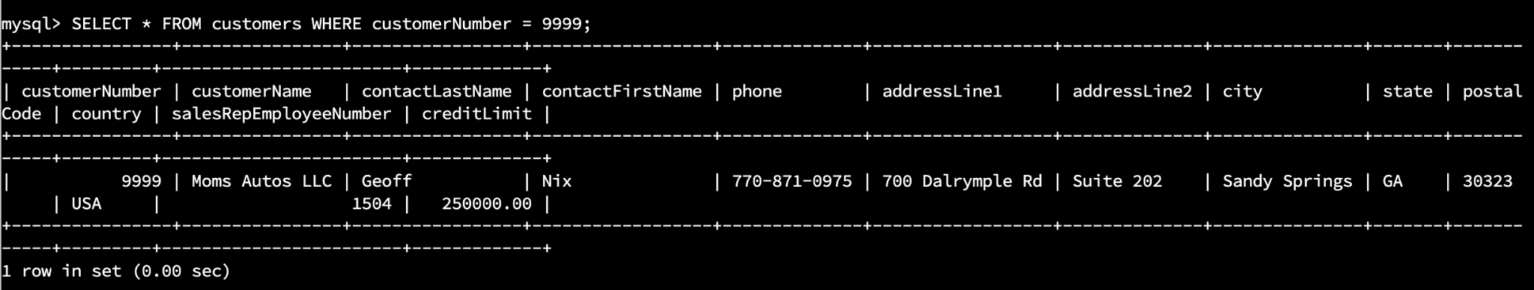

1. **Reflection**
   1. **Define how cardinality is applied** to the databases you’ve been working with and why different numbers of records returned from the different offices.
   2. Cardinality refers to the uniqueness of data in a specific column of a table. The database has various tables that have different cardinality from other tables. The queries used have different clauses that produce different tables when the data is joined based on the common columns.
   3. **Compare and contrast** the different **queries** you ran and how cardinality applies to them.
      1. The ‘WHERE” clause will determine how two or more tables relate. Using ‘WHERE’ in the customer number ‘1504’ query was specific to that one employee and produced a table specific to that particular employee. Using ‘WHERE’ in the query for state yielded a larger table as a state can have many customers and employees
   4. **Describe two** of the crucial **benefits** **of cardinality** in this type of database.
      1. Cardinality allows you to combine the data from several tables and join them based on common attributes. This helps analyze data and prevent duplicates.